Problem Statement:

Propose a serial kinematic chain robotic manipulator to solve the following problems, what type of manipulator can be used for the Construction robot to lay clay bricks while constructing a wall. The robot should be able to carry a stack of bricks (about 10) and mortar (mixture of cement, sand, and water) during the activity.

1. Select serial kinematic chain to perform the desired task effectively. Justify your selected kinematic chainwith strong arguments in favor of selected task. Provide the sketch of kinematic chain model using some software graphical tools such as RVC Toolbox in MATLAB, Robo-Analyzer etc. In addition, mention the joint limits for all joint

Proposed Kinematic Chain:

First of all I have also included some assumptions which are as:

* The chain should be able to withstand 20bricks as well as 40Kg of cement
* It should be able to transfer it simultaneously through a height of 5m
* Each brick weights 1.5kg

The Kinematic chain that is most suitable for this activity is 6DOF articulated manipulator.

Arguments:

1. The articulated manipulator is a superior choice for the construction project due to its higher degrees of freedom, which allow for greater flexibility and range of motion.

2. The 6DOF articulated manipulator is well-suited to handle the project requirements of transferring 20 bricks and 40kg of cement simultaneously through a height of 5 meters, with each link having a length of 5m.

3. The joint limits for the 6DOF articulated manipulator are within safe and practical ranges for the given task and can be adjusted as necessary for optimal performance.

4. While other manipulator options may also be suitable for this project, the articulated manipulator stands out as the most reliable and efficient choice based on its technical capabilities and practical application in the construction industry.

5. The articulated manipulator's ability to perform complex and precise movements, along with its versatility in handling a range of materials, makes it an ideal candidate for a variety of construction tasks beyond brick-laying.

Competitors:

There are several types of robotic manipulators that could potentially be used for this task, but they may not be as suitable as the chosen manipulator for the following reasons:

1. SCARA Manipulator: A SCARA (Selective Compliance Articulated Robot Arm) manipulator is a popular choice for pick and place operations, but it may not be the best choice for this task as it has limited vertical reach and may not be able to transfer the bricks and mortar to the required height.

2. Delta Manipulator: A Delta manipulator is a parallel manipulator that is known for its high speed and precision, but it may not be suitable for this task as it has limited payload capacity and may not be able to handle the weight of the bricks and mortar.

3. Polar Manipulator: A polar manipulator is a type of articulated manipulator that uses a rotary joint to provide rotation about a fixed base. While it has good dexterity and can reach a wide range of positions, it may not be as suitable for this task as it has limited vertical reach and may not be able to transfer the bricks and mortar to the required height.

Joint Limits:

The joint limits for the articulated manipulator would be as follows:

- Joint 1 (base rotation): -180 to 180 degrees

- Joint 2 (shoulder pitch): -45 to 225 degrees

- Joint 3 (elbow pitch): -180 to 0 degrees

- Joint 4 (wrist pitch): -90 to 90 degrees

- Joint 5 (wrist roll): -180 to 180 degrees

- Joint 6 (end-effector rotation): -180 to 180 degrees

These joint limits ensure that the manipulator can reach the desired height of 5 meters while also being able to lift and transfer the required weight of 20 bricks and 40 kg of cement. It also allows for a wide range of motion and flexibility in the manipulator's movement. It is to be noted that each link has a length of 5m.

Kinematic Chain In MATLAB:

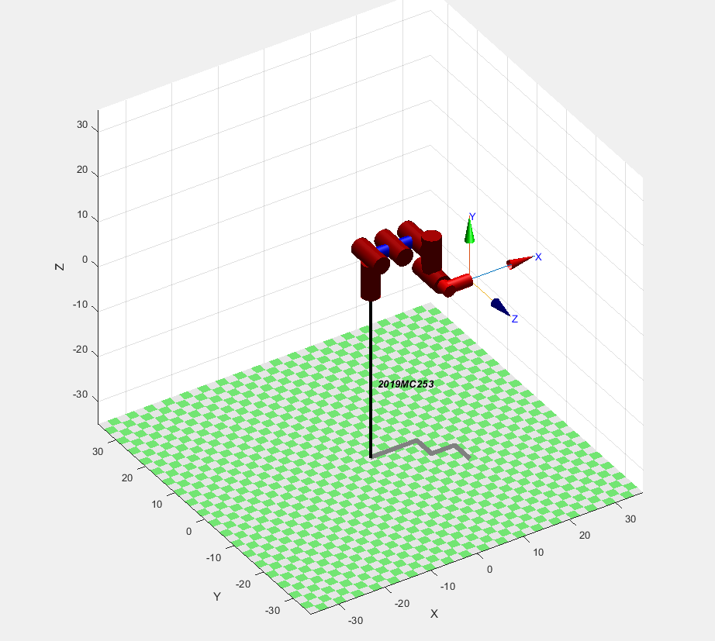

Figure Illustrating the 6DOF kinematic chain

1. Solve Forward Kinematics for the kinematic chain selected in (a). Suggest, an Inverse Kinematic solution for the kinematic chain selected in (a).

There are two possible ways to calculate the Forward Kinematics which are by hand and by software. I’m using the later as it would be more precise and feasible. Although if asked I would provide the hand written calculations as well.

DH Table:

|  |  |  |  |  |
| --- | --- | --- | --- | --- |
| i | alpha(i-1) | a(i-1) | d(i) | theta(i) |
| 1 | 0 | 0 | L1 | 0 |
| 2 | pi/2 | 0 | 0 | 0 |
| 3 | 0 | L2 | 0 | 0 |
| 4 | 0 | L3 | L4 | 0 |
| 5 | pi/2 | 0 | L5 | 0 |
| 6 | 0 | 0 | L6 | 0 |

Figure2 Illustrating the DH Table for the 6DOF kinematic chain

Forward Kinematics:

The code to Calculate the forward Kinematics is as:

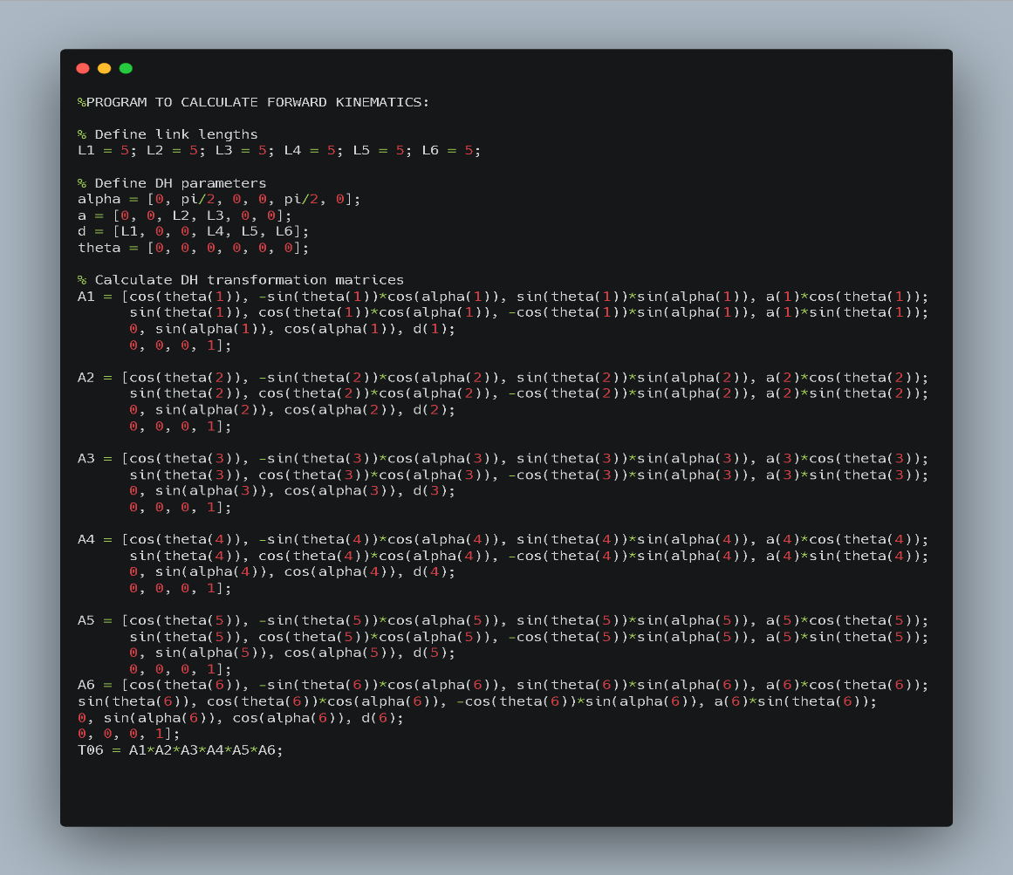

The Matrices involved are as:

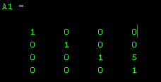 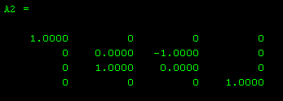

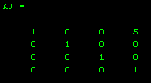 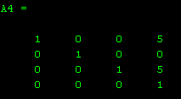

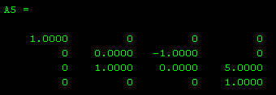 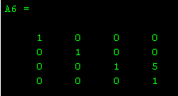

Inverse Kinematics Solution:

There are multiple methods to solve the inverse kinematics problem, such as analytical methods, geometric methods, and numerical methods.But we are